**Project Title: Academic Management System (using SQL)**

1. Database Creation:

a) Create the StudentInfo table with columns STU_ ID, STU_NAME, DOB, PHONE_NO, EMAIL_ID,ADDRESS.

CREATE TABLE StudentInfo (STU_ID INT PRIMARY KEY,  
STU_NAME VARCHAR(100),  
DOB DATE,  
PHONE_NO VARCHAR(20),  
EMAIL_ID VARCHAR(100),  
ADDRESS VARCHAR(255));

b) Create the CoursesInfo table with columns COURSE_ID, COURSE_NAME,COURSE_INSTRUCTOR NAME.

CREATE TABLE CoursesInfo (COURSE_ID INT PRIMARY KEY,  
COURSE_NAME VARCHAR(100),  
COURSE_INSTRUCTOR_NAME VARCHAR(100));

c) Create the EnrollmentInfo with columns ENROLLMENT_ID, STU_ ID, COURSE_ID, ENROLL_STATUS(Enrolled/Not Enrolled). The FOREIGN KEY constraint in the EnrollmentInfo table references the STU_ID column in the StudentInfo table and the COURSE_ID column in the CoursesInfo table.

CREATE TABLE EnrollmentInfo (ENROLLMENT_ID INT PRIMARY KEY,  
STU_ID INT,  
COURSE_ID INT,  
ENROLL_STATUS VARCHAR(20),  
FOREIGN KEY (STU_ID) REFERENCES StudentInfo(STU_ID),  
FOREIGN KEY (COURSE_ID) REFERENCES CoursesInfo(COURSE_ID));

2. Data Creation: Insert some sample data for StudentInfo table , CoursesInfo table, EnrollmentInfo with respective fields.

INSERT INTO StudentInfo (STU_ID, STU_NAME, DOB, PHONE_NO, EMAIL_ID, ADDRESS)

VALUES (1, 'Will Smith', '2000-01-01', '1234567890', 'will.smith@email.com', '543 Ricky St'),  
(2, 'JK Rowling', '2001-02-02', '9876543210', 'jk.rowling@email.com', '189 Rocky St');

INSERT INTO CoursesInfo (COURSE_ID, COURSE_NAME, COURSE_INSTRUCTOR_NAME)  
VALUES (101, 'Mathematics', 'James'),  
(102, 'Computer Science', 'Josesph');

INSERT INTO EnrollmentInfo (ENROLLMENT_ID, STU_ID, COURSE_ID, ENROLL_STATUS)  
VALUES (1, 1, 101, 'Enrolled'),  
(2, 1, 102, 'Enrolled'),  
(3, 2, 101, 'Enrolled');

3) Retrieve the Student Information

a) Write a query to retrieve student details, such as student name, contact informations, and Enrollment status.

SELECT DISTINCT(s.STU_NAME), s.PHONE_NO, s.EMAIL_ID, e.ENROLL_STATUS  
FROM StudentInfo s  
JOIN EnrollmentInfo e ON s.STU_ID = e.STU_ID;

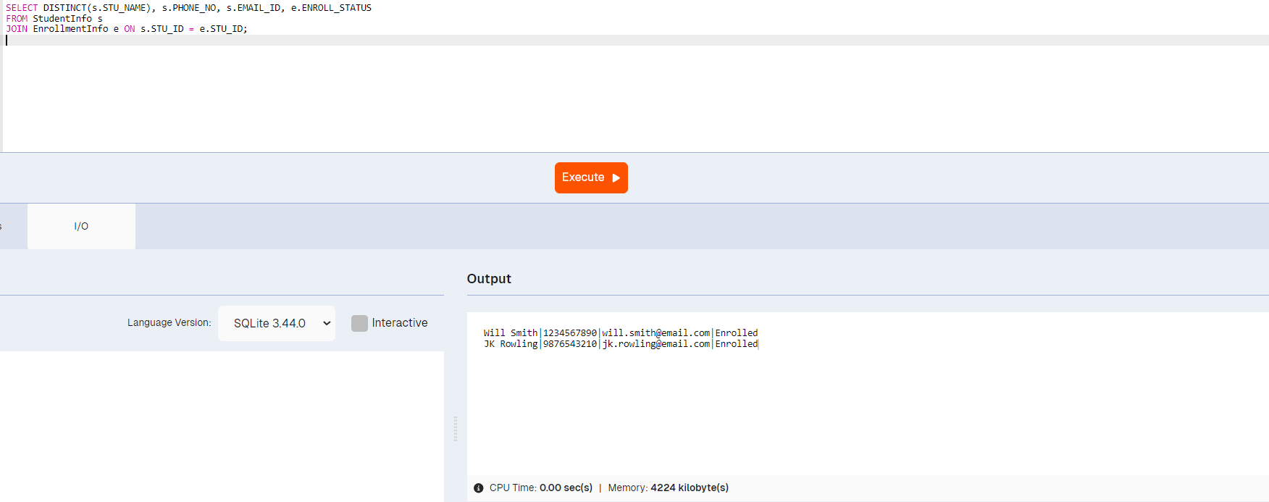

b) Write a query to retrieve a list of courses in which a specific student is enrolled.

SELECT c.COURSE_NAME  
FROM CoursesInfo c  
JOIN EnrollmentInfo e ON c.COURSE_ID = e.COURSE_ID  
WHERE e.STU_ID = 1;

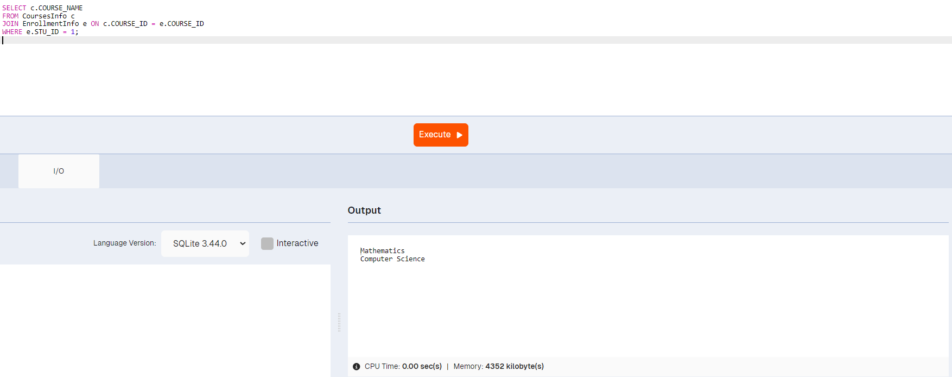

c) Write a query to retrieve course information, including course name, instructor information.

SELECT COURSE_NAME, COURSE_INSTRUCTOR_NAME FROM CoursesInfo;

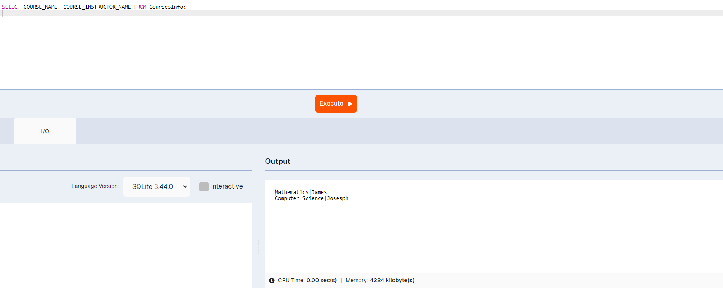

d) Write a query to retrieve course information for a specific course.

SELECT * FROM CoursesInfo  
WHERE COURSE_ID = 101;

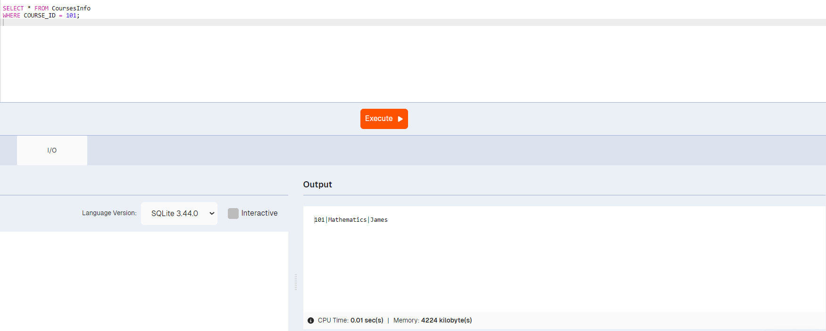

e) Write a query to retrieve course information for multiple courses.

SELECT * FROM CoursesInfo  
WHERE COURSE_ID IN (101, 102);

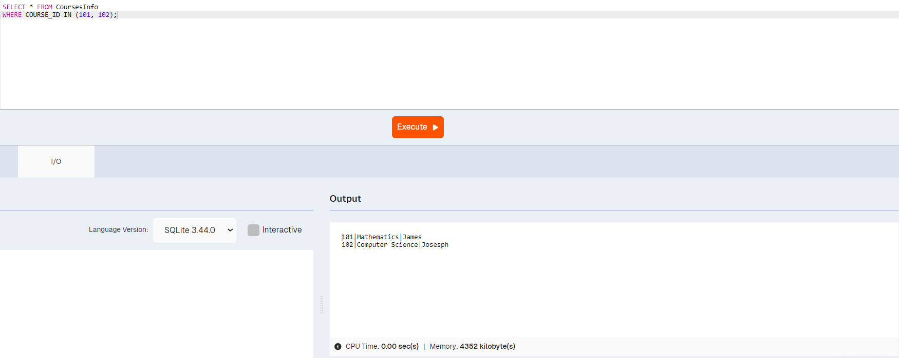

f) Test the queries to ensure accurate retrieval of student information.( execute the queries and verify the results against the expected output.)

4. Reporting and Analytics (Using joining queries)

a) Write a query to retrieve the number of students enrolled in each course

SELECT c.COURSE_NAME, COUNT(e.STU_ID) AS NUM_ENROLLED FROM CoursesInfo c  
LEFT JOIN EnrollmentInfo e ON c.COURSE_ID = e.COURSE_ID  
GROUP BY c.COURSE_NAME;

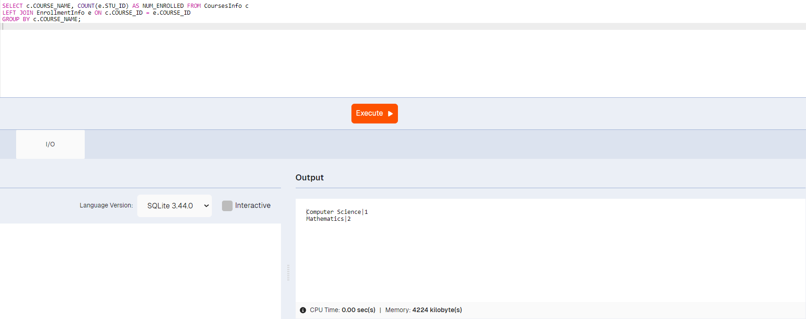

b) Write a query to retrieve the list of students enrolled in a specific course

SELECT s.STU_NAME FROM StudentInfo s  
JOIN EnrollmentInfo e ON s.STU_ID = e.STU_ID  
WHERE e.COURSE_ID = 101;

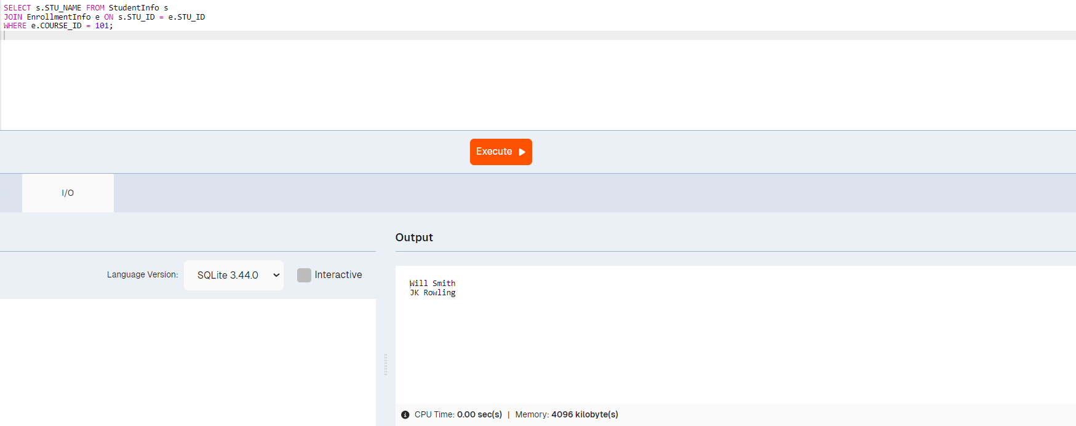

c) Write a query to retrieve the count of enrolled students for each instructor

SELECT c.COURSE_INSTRUCTOR_NAME, COUNT(e.STU_ID) AS NUM_ENROLLED FROM CoursesInfo c  
JOIN EnrollmentInfo e ON c.COURSE_ID = e.COURSE_ID  
GROUP BY c.COURSE_INSTRUCTOR_NAME;

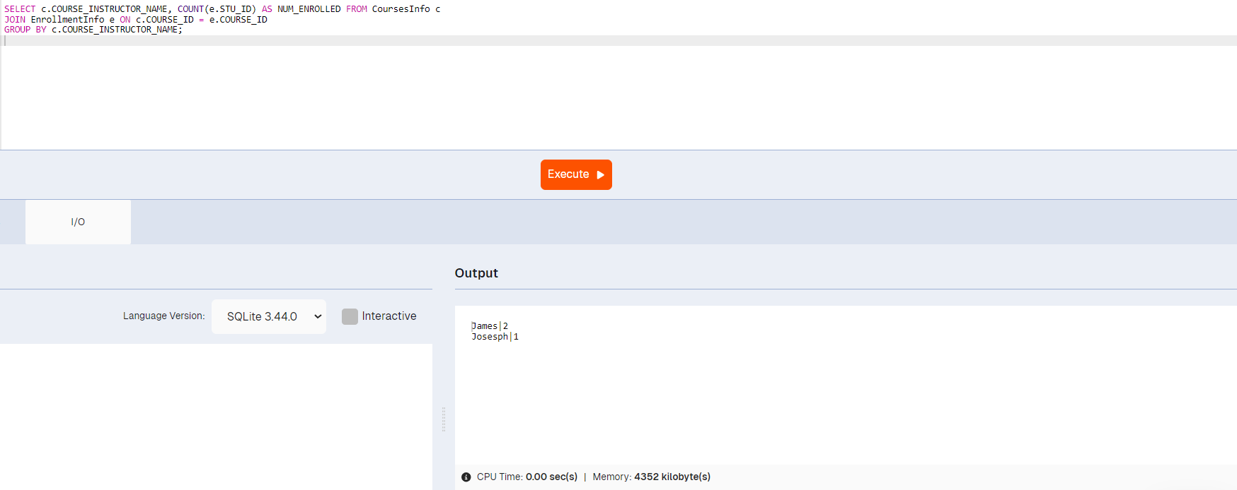

d) Write a query to retrieve the list of students who are enrolled in multiple courses

SELECT s.STU_NAME FROM StudentInfo s  
JOIN EnrollmentInfo e ON s.STU_ID = e.STU_ID  
GROUP BY s.STU_ID HAVING COUNT(e.COURSE_ID) > 1;

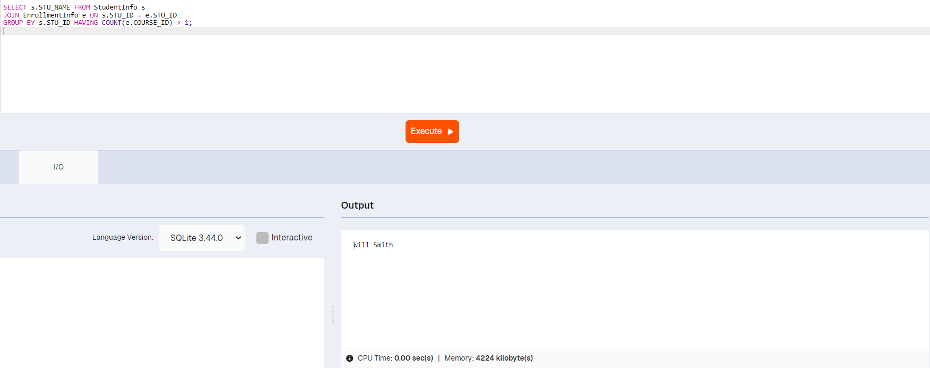

e) Write a query to retrieve the courses that have the highest number of enrolled students(arranging from highest to lowest)

SELECT c.COURSE_NAME, COUNT(e.STU_ID) AS NUM_ENROLLED FROM CoursesInfo c  
JOIN EnrollmentInfo e ON c.COURSE_ID = e.COURSE_ID  
GROUP BY c.COURSE_NAME ORDER BY NUM_ENROLLED DESC;

